
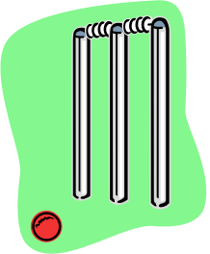
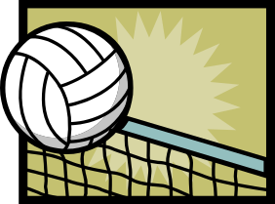
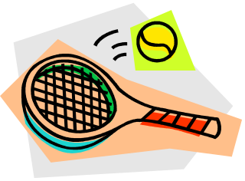
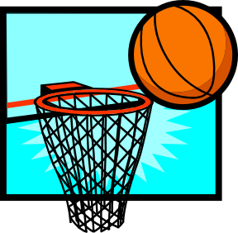
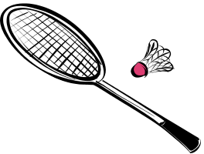
http://www.trinity.nottingham.sch.uk/pe/gcse/courseContent/revisionBooklet.doc
This document has been kindly put together by Mr Lewis Slater, on behalf of the Physical Education Department.

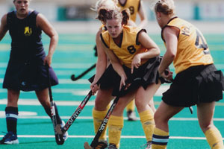
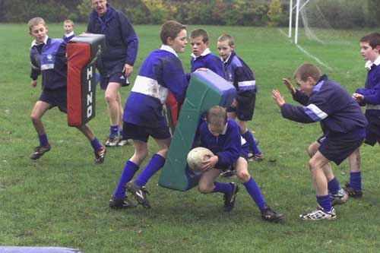

Develops friendships and social mixing
Help relieves stress/tension & Stress related illness

Contributes to good health and enjoyment of life

Enhances body shape

Helps individual to feel and look good
REASONS FOR
PARTICIPATING IN
PHYSICAL ACTIVITY
SECTION A: EXERCISE and TRAINING

A1 - Reasons for taking part in activity

Aesthetic appreciation

Physical Challenge

Competition

Co-operation

BENEFITS OF
SPORTING CLUBS & PARTICIPATION

SOCIAL | MENTAL | PHYSICAL
- Develops friendships and social mixing  - Co-operation  - Competition  - Physical Challenge  - Aesthetic appreciation | - Helps relieves stress/tension  - Helps relieve stress related illness | - Helps individual to feel and look good  - Enhances body shape  - Contributes to good health and enjoyment of life

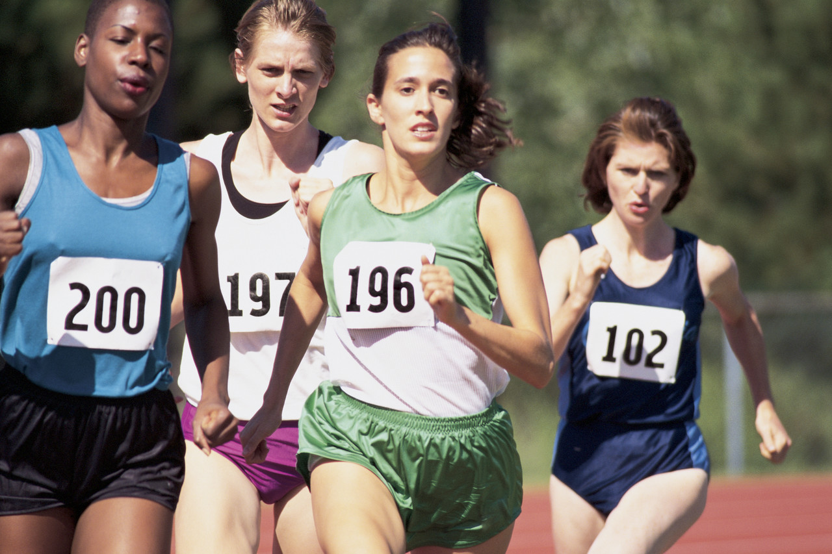
A2 - HEALTH, FITNESS, EXERCISE and PERFORMANCE
KEY DEFINITIONS

- Health – State of complete mental, physical and social well-being.
- Fitness – The ability to meet demands of the environment
- Exercise – Form of physical activity done primarily to improve one’s health and physical fitness

CARDIOVASCULAR FITNESS – the ability of the heart to pump blood and deliver oxygen where needed in the body. Relies on a healthy heart, blood and blood vessels
Examples
- Playing 90 minutes in football matches
- Playing Cricket matches that could last for 3-5 days
- Running in a marathon

FLEXIBILITY – movement at a joint to its fullest range
MUSCULAR ENDURANCE – The ability of muscles to move weight over a long period without tiring

Examples
- Hurdling in athletics
- Gymnastics – performing complex sequences
- Swimming -
Examples
- Long distance walking
- Long distance running
- Long distance swimming
HEALTH RELATED COMPONENTS

SPEED – Fastest rate at which a person can complete a task or cover a distance
STRENGTH is defined as the ability to lift a maximum weight in one attempt
Muscular strength – Can be seen in person lifting heavy weights.

Examples
- Running fast – 100m sprint
- Throwing a cricket ball at the stumps to get a run out

Examples
- DYNAMIC – required to start and maintain movement of the body e.g. cycling or doing loads of press-ups
- EXPLOSIVE – required when a high amount of force has to be applied quickly e.g. shot putting
- STATIC – required when applying strength to a fixed static object e.g. pushing in a rugby scrum

REACTION TIME – The time it takes to respond to a stimulus (simple) or a variety of stimuli (choice)
A3 - SKILL RELATED FITNESS
Examples
- SIMPLE – responding to a signal e.g. sprint start to a gun
- CHOICE – responding to a variety of signals e.g. playing a shot in cricket depending on length of the ball pitched

POWER – Ability to apply a combination of speed and strength in an action
AGILITY – Ability to change direction quickly and still be in control

SKILL COMPONENTS
Examples
- Football - dribbling past an opponent at speed
- Rugby – Running, avoiding opponents whilst in possession
Examples
- Football – Goal keeper taking a goal kick
- Badminton – playing an overhead smash

BALANCE – Ability to keep the body stable whether still (static), moving (dynamic) or in a different shape by keeping centre of gravity over the base
CO-ORDINATION – Ability to use two or more parts of the body at the same time

Examples
- Pole vaulting
- Basketball – lay up shot
- Tennis – player taking a serve
Examples
- STATIC – holding a position without movement e.g. a handstand in gymnastics
- DYNAMIC – maintaining a position whilst moving e.g. cycling or surfing

A4 - PRINCIPLES OF TRAINING
There are several training principles, each influencing the training of the performer in a different way. Good training takes into account all of the principles and their effects on the body.

S.P.O.R.T. Principles

- SPECIFICITY – Understanding the needs of the game or event, e.g. a goalkeeper will include reaction work in their training. The pace of training should be consistent to the pace of the game. Also the actions should be the same in training as it is in match situations e.g. a swimmer needs to spend most of their time in the water.
- PROGRESSION - Exercising at the same degree of difficulty all the time will only maintain current fitness levels. Your body needs to be put under more pressure in order to improve. The easier a session is to complete, the performer should start to progress the next session.
- OVERLOAD – Putting greater demands on the body by exercising. This can improve fitness. The point where exercise is demanding enough to have an effect on the body is called the ‘threshold of training’. There 3 ways;
- Frequency – number of sessions e.g. up to 3 per week
- Intensity – increasing distances run, repetitions or weight
- Duration – length of training sessions
- REVERSIBILTY – The body will increase in strength, tone and skill with exercise; however it also loses them without it. After injury or illness, an athlete can lose their strength and skill, up to 3x as fast as they gain it – ‘If you don’t use it, You lose it!’
- TEDIUM – Use different ways of training to give variety, keep interest and avoid boredom.
e.g. go bike riding instead of running

- INDIVIDUAL NEEDS - Whether training to compete or training for health, everyone has different needs. People vary in height, size, shape and preference. Therefore, even though they have the same goals they may not reach them by the same means.
F.I.T.T PRINCIPLES

FREQUENCY – How often the exercise is done (be it an individual set or the whole session) – e.g. Training 3 times a week or 2 per day. Elite performers train more frequently to achieve results good enough. Remember, the body needs time to recover so training very, very hard, every day can be harmful even to an elite performer.

INTENSITY – The difficulty of the exercise – could be the amount of weight or the speed you move. Consider cardiovascular fitness, your pulse rate can show you how intensely you’re working. Fitness will increase by working in 60-80% target zone of the maximum heart rate, e.g. Training with heart rate of 120bpm – 160bpm. Strength training is similar, by calculating 60-80% of their maximum weight they can lift and working to it.

TIME – The duration of the Exercise. Keeping your pulse at 60-80% of its maximum for 2minutes is the target. The time begins once the pulse rate hits 60%. The warm up is not included. Also you can vary the duration of each session e.g. 30mins, 45mins or 60mins

TYPE – What kind of exercise you do – For general fitness then personal preference to suit the individual is usually done e.g. swimming, cycling or running, But if its for a specific activity then choice becomes limited as it should reflect the activity. However remember to vary to keep interesting and work all different muscle groups.

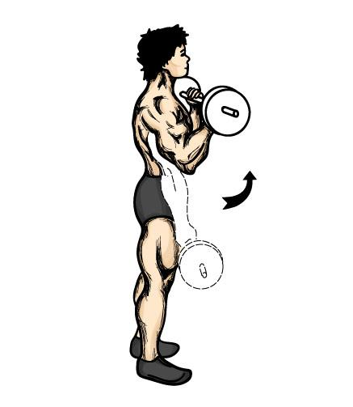
A5 - METHODS OF TRAINING

TYPES OF CONTRACTION

- Isotonic Contraction – In this contraction, the muscle changes length and so something moves. E.g. Bicep Curl

- Isometric Contraction – In this contraction, the muscle stays the same length and so nothing moves. E.g. the Wall Sit
AEROBIC and ANAEROBIC ACTIVITY

Aerobic – with oxygen
- Lower intensity
- Endurance activities - Marathon

Anaerobic – without oxygen
- Higher intensity
- Short distance activities - Sprinting

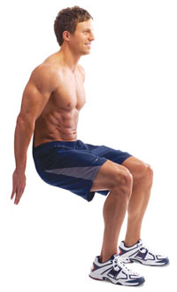

TRAINING METHODS

There are many types of training methods.

- CIRCUIT TRAINING – Has between 8 – 15 stations in it. Each station has a specific exercise to do. A short rest is allowed between each station.
- WEIGHT TRAINING – Improves muscle strength and tone. Be done in a gym using free weights.
- INTERVAL TRAINING – Mixing periods of hard exercise and rest periods. Similarity to games activities e.g. Rugby and Football
- CONTINOUS TRAINING – Exercising aerobically at a constant rate doing activities like running or cycling, with no rests.
- FARTLEK TRAINING – Swedish for ‘speed play’ - Changing speed, distances and times of exercise in same session.
- CROSS TRAINING – Uses a combination of different training methods.

Effects of Exercise on the Body

Immediate Effects of Exercise | Effects of Regular Training | Long Term Benefits
Heart Rate increases | Bigger and Stronger Heart -Athletes heart | Helps prevent Heart Disease
Cardiac Output & Stroke Volume increases | Lower Resting Heart Rate | Helps prevent Type 2 diabetes
Blood Pressure increases | Improve Cardiac Output &  Stroke Volume | Helps prevent Cardiovascular Disease
Increase of Blood to working muscles | Lower Blood Pressure | Helps prevent Obesity
Skin becomes Red – Vasodilation of blood vessels | More Blood Vessels - Capillarisation | Improves General & Mental Health
Increase Tidal Volume | Improved VO2 Max | Helps prevent depression
Increase breathing rate – more Oxygen uptake | More efficient gaseous exchange | Boosts Immune System
Increase in Gaseous exchange – more blood to lungs | Stronger muscles, ligaments, tendons
Increase Flexibility in Muscles and joints
Sweat Production

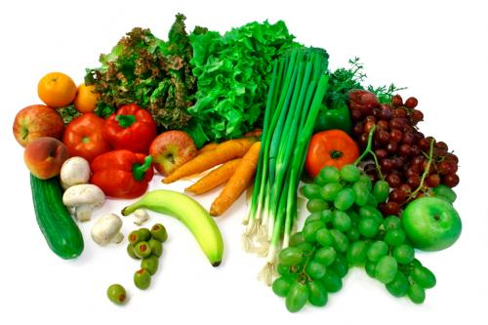
A6 - DIET, HEALTH AND HYGIENE

 | Function | Foods found in | Aid to Sportsperson
Carbohydrates | Ready source of energy  Store of energy as Glycogen | Fruit, cakes, beer, sweets, granulated sugar and bread, pasta rice, potatoes. | Ready source of energy when muscles need it. Athletes training hard use carbohydrates quickly so diet should be high in this food type.
Proteins | Growth and Repair of tissues, enzymes and hormones | Meat, fish, pulses (chick peas, lentils and beans), nuts, eggs and poultry | Builds muscle and repairs tissue within body. Essential after injury to heal quickly. Sportspeople who have large muscles need extra protein.
Fats | Source of energy (slow release)  Can be stored in body | Milk, cheese, butter, oils, chocolate, fatty meats, soya beans and corn. | Increase size and weight of body beneficial to performers with extra bulk e.g. Shot putter. Excess weight can inhibit performance though.
Vitamins | Helps general health – vision, skin condition, forming of red blood cells and clotting, good condition of bones and teeth | Fruit – vitamin C  Liver, carrots – Vitamin A  Whole grain, nuts – Vit B1  Vegetable oil – Vitamin E | General health is important to perform well. When training hard vitamins from B group are used up more so need replenishing.
Minerals | Calcium helps growth of bones, Iron helps making red blood cells and the way blood is carried by haemoglobin. | Milk and salt water fish (iodine), red meat, liver and green vegetables (iron), cheese and cereal. | Increase oxygen carrying capacity to working muscles. Iodine aids growth, essential for athlete’s energy production. Iron helps produce red blood cells so carry more oxygen around body preventing fatigue. Calcium helps blood to clot, aiding recovery and strengthens bones and muscles.
Fibre | Helps Digestion. There are 2 types.  - Insoluble – adds bulk to food so moves through digestive system  - Soluble – helps reduce cholesterol, keeping heart healthy | Leaves, seed cases, cereals and whole grains. | Less Cholesterol in the body makes the heart more efficient  By keeping digestive system functioning regularly the body retains less waste
Water | Two-thirds of the body is water  Need to replenish water which is lost in urine, sweat and condensation when we breathe | Fluids and foods | Water allows blood to flow more easily – important when exercising as the body demands more oxygen, nutrients, heat control and waste removal.

BALANCED DIET – Daily intake of food containing right amounts and types of nutrients

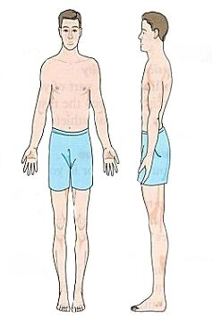
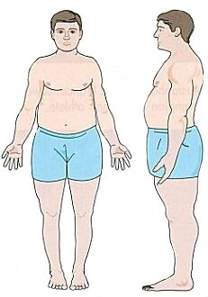
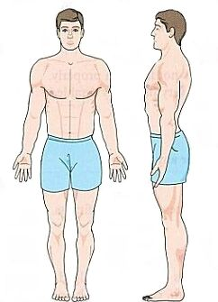
WHAT ARE THE DIFFERENT SOMATOTYPES?

ECTOMORPH
- Slightly built, delicate body
- Narrow shoulders and hips
- Lean, fragile
- E.G. Marathon Runner

MESOMORPH
- ‘Athletic Build’
- Muscular, large trunk
- Broad shoulders, narrow hips
- E.G. 100m Sprinter

ENDOMORPH
- Round/ ‘pear drop’ shape
- Narrow shoulders and broad hips
- Carry weight around waist and on hips and upper thighs
- E.G. Sumo wrestler

DEFINITIONS

OVERWEIGHT – having weight excess than normal, harmless unless accompanied with over fatness

OVER FAT – person having more fat than recommended for gender and age

OBESE – term used to describe people who are very over fat

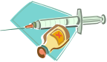
DRUGS
ALCOHOL
- Affects co-ordination, speech and
Judgement
- Slows your reactions
- Makes your muscles tire quickly
- Eventually damages heart, liver,
kidneys, brain, muscles and digestive
and immune

SMOKING
- Causes nose, throat and chest
Irritations
- Makes you short of breath
- Increases risk of developing heart
disease, lung cancer and bronchitis
and other diseases

‘LEGAL BUT HARMFUL’

PERFORMANCE ENHANCING DRUGS
These drugs are banned by the International Olympic Committee (IOC)

S.N.A.P.D | Advantages | Disadvantages
Stimulants | - Speeds up reactions and increases aggression  - Make you feel less pain | - Feeling less pain can make athlete train too hard  - Lead to high blood pressure, heart and liver problems, and strokes  - They’re addictive
Narcotic Analgesics | - Kill pain – so injuries and fatigue doesn’t affect performance | - Addictive with unpleasant withdrawal symptoms  - Feeling less pain can make athlete train too hard  - Lead to constipation and low blood pressure
Anabolic Steroids | - Increase Muscle size  - Allow athletes to train harder | - Cause high blood pressure, heart disease, infertility and cancer  - Women may facial and body hair, and their voices may deepen
Peptide Hormones | - Most have similar effects as anabolic steroids  - EPO – allows more oxygen carrying capacity due increase of red blood cells | - Cause strokes and abnormal growth
Diuretics | - Weight loss – important if competing in a certain weight division  - Can mask traces of other drugs in body | - Cause cramp and dehydration
‘B CALM’ DRUGS
The IOC RESTRICTS the use of these drugs
HYGIENE
Hygiene means the different ways to keep our body clean and healthy.
Good hygiene helps to keep us healthy.
- Healthy skin = resist most infections
- Clothing should be washed and changed regularly
- Nails should be cut and cleaned so reduces injury
- Jewellery – pierced ears and earrings should be cleaned carefully to prevent infection
- Hair should be washed regularly to keep it clean and healthy
- Teeth should be brushed at least twice a day to be healthy
- Feet should be washed regularly and dried carefully. Also change socks to avoid odour
B CALM
Beta Blockers | - Lower heart rate, steady shaking hands and reduce anxiety  - Banned in sports it may ban advantage – Snooker, shooting
Corticosteroids | - Help reduce pain and inflammation from injuries  - Serious side effects – depression, diabetes
Alcohol | - Calms nerves and can be used in snooker or shooting
Local Anesthetics | - Reduce pain but maybe allowed for medical purposes
Marijuana | - Calms nerves and can be used in snooker or shooting

 | Athlete’s Foot | Verrucae
Recognition | Feet smell  Skin flakes  Itching & irritation | Viral wart  painful when applying pressure
Treatment | Wash feet regularly  Wear clean socks  Dry between toes | Applying creams  Medically remove
Prevention | Use foot powder from chemist | Wearing verruca sock

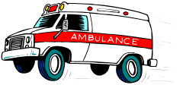
B1 - PREVENTION OF INJURY

SECTION B: Safety aspects & risk assessment in sport & physical activity

Warm-up and cool-down practices
Understand Rules of the game

HOW TO PREVENT INJURY

Balance competition in terms of

- Grading  - Skill levels  - Age | - Weight  - Sex

Wearing correct clothing/footwear;
Protective clothing/equipment for different sports

B2 - SPORTS INJURIES

EMERGENCIES – WHEN SOMEONE COLLAPSES

RECOVERY POSITION
When a person is unconscious we place them in this position to prevent them:
- from being sick
- from choking
- from their tongue falling back and blocking the airway
After placing a person in this position, dial 999 for help. You must keep checking their breathing every 2-3 minutes until help arrives.
DANGER | Ask - am I in danger? ... Is the collapsed person in danger?  Send for medical help
RESPONSE | Conscious | Unconscious
AIRWAY | - Make comfortable  - Check Airway, Breathing, Circulation  - Check for injury | - Put in recovery position  - Clear airway & tilt head  - Look, listen, feel for breathing
BREATHING | Breathing  - Keep in recovery position  - Check Airway, Breathing,  Circulation  - Check for injury | Not Breathing  - Put on back  - Start mouth to mouth ventilation  - Give 2 full breaths  - Check circulation
CIRCULATION | Pulse Present  - Keep on back  - Continue M.M.V  - Check pulse & breathing | Pulse Absent  - Start cardiopulmonary resuscitation  (CPR)  - Check pulse & breathing
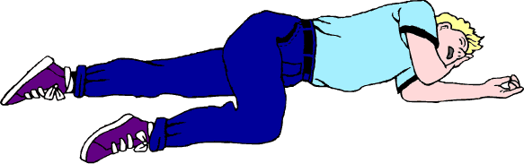
RECOVERY POSITION
We place an unconscious person in this position to prevent them:
- From being sick
- From choking
- From their tongue falling back and blocking the airway

After placing a person in this position, dial 999 for help.
You must keep checking their breathing every 2-3 minutes until help arrives.

SPORTS INJURIES continued…

HARD TISSUE INJURIES
These are injuries to the bone and include;
- Fractures
- Dislocations

FRACTURES – break in the bone. There are two types;
  - Simple (closed) fracture– bone stays under the skin
  - Compound (open) fracture – Bone breaks through the skin

*All fractures are serious and need URGENT medical attention*

STRESS FRACTURES – Small cracks in the bone. Often an overuse injury and caused by running too much in a hard surface. We need to;
- Use ice to reduce inflammation
- Get immediate rest
- Keep fit doing over activities
- Check running and footwear for problems

DISLOCATIONS – Bone at a joint is forced out of its normal position.

Also could be possible ligament damage around the joint. Could be caused by strong force wrenching the bone e.g. rugby tackle.
All dislocations should be treated as a fracture.

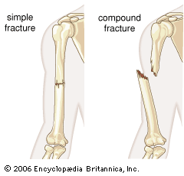
1
2

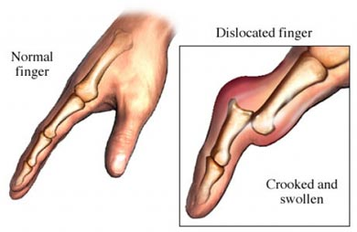

SOFT TISSUE INJURIES
Includes;
- Sprains
- Strains
- Cartilage damage
- Tendon and ligament damage
- Minor injuries – cuts, grazes and bruises

TREATMENT – R.I.C.E

REST – Rest the injured part to prevent further injury

ICE – Apply ice or a cold compress to reduce blood flow, pain and swelling

COMPRESSION – Compress the injury to reduce bleeding and swelling

ELEVATION – Elevate the injured part to reduce bleeding, swelling and throbbing

BONE & JOINT INJURIES

RECOIGNITION
- Recent blow or fall
- Snapping sound
- Difficulty moving limb
- Pain worse when moving
- Deformity – limb unusual shape
- Swelling, bruising
- Signs of shock
ACTION
- Keep him/her still & comfortable
- Support injured part
- Bandage injured part to their body/limb
- Reassure him/her
- Send for medical help

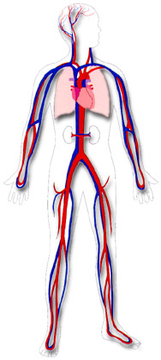
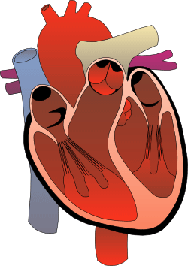
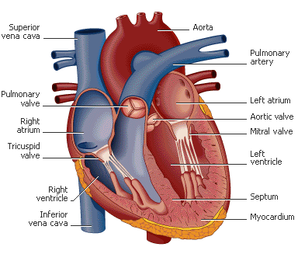
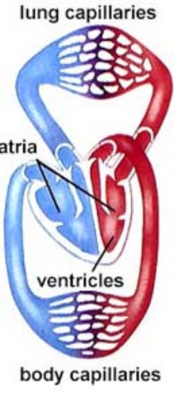
Veins:
Thin walls
Valves present; prevents backflow. No pulse
Pulsating muscles close to veins prevent backflow- ‘skeletal pump’
Work under low pressure
Transports blood towards the heart (DEOXYGENATED)
Wide lumen
Capillaries:
Smallest of all vessels – walls one cell thick
They are ‘semi-permeable’ – substances pass through
At one end – they feed muscles, organs and body tissue with oxygen and nutrients
At other end – carbon dioxide and waste products pass into veins to be removed
They bring blood within reach of every cell

THE FLOW OF BLOOD
De-oxygenated blood returns to the heart through the large veins called venae cavae

Blood enters right atrium and passes through the tricuspid valve into right ventricle

It is then pumped through the semi-lunar valve into pulmonary artery and into lungs where it loses carbon dioxide and picks up fresh oxygen

Oxygenated blood returns to heart from lungs through the pulmonary vein into left atrium

It passes through bicuspid valve and into the left ventricle

It is pumped through semi-lunar valve into aorta and out to rest of body through arteries

Systemic Circuit
Pulmonary Circuit
Arteries
Veins
C1 - THE CIRCULATORY SYSTEM
WHAT ARE ARTERIES, VEINS & CAPILLARIES?
Arteries:
- Thick, flexible vessel walls
- Has a pulse. No valves
- Work under high pressure
- Transports blood away from heart (OXYGENATED)
- Narrow lumen
WHAT ARE THE COMPONENTS OF THE BLOOD?
- Red blood cells – made in bone marrow of long bones. Carry oxygen and transport nutrients and waste products
- White blood cells – made in bone marrow and lymph tissue. Protect body from disease
- Platelets – in charge of blood clotting. Clotting is important to stop blood loss from the body and stop internal bleeding
- Plasma – made up of mostly water and makes up 55% of volume of blood; helps blood fluidity
KEY TERMS
- Heart Rate (HR) – the amount of beats per minute
- Stroke Volume (SV) – the amount of blood pumped by heart in one beat
- Cardiac Output (CO) - the amount of blood pumped by the heart in one minute
CO = SV X HR
Heart
Lungs
THE HEART
Section C: Applied anatomy & physiology

The 3 parts of the circulatory system are blood, heart and blood vessels
C2 - THE RESPIRATORY SYSTEM
THE RESPIRATORY SYSTEM
The function of the respiratory system is;
- To get oxygen into the body
- To remove carbon dioxide out of the body
Oxygen is used by the body to release energy and carbon dioxide is released so it doesn’t build up and poison the body

The 3 parts of the respiratory system are the diaphragm, lungs and air passages
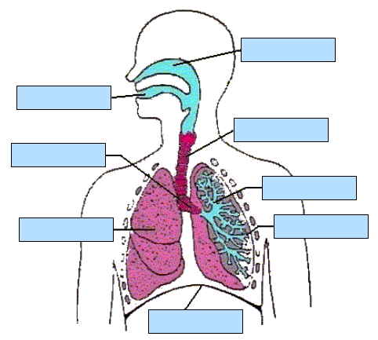
When we breathe in – Inspiration – the following happens… | When we breathe in – Expiration – the following happens…
- Our diaphragm pulls down  - Our intercostal muscles contract  - Air pressure is reduced  - Air is sucked through the tubes into lungs  - Our chest expands | - Our diaphragm relaxes  - Our intercostal muscles relax  - Our chest becomes smaller  - Pressure increases on the lungs  - Air is forced out
COMPOSITION OF AIR

INHALED AIR
- 79% - Nitrogen
- 20% - Oxygen
- Trace - Carbon dioxide
EXHALED AIR
- 79% - Nitrogen
- 16% - Oxygen
- 4% - Carbon dioxide
WHAT IS LACTIC ACID?
- Lactic acid is a bi-product of exercise. A build up of this can inhibit performance and cause pain, discomfort and fatigue.
- Lactic acid occurs in the anaerobic system because without the presence of oxygen, pyruvic acid turns to lactic acid.
- Cooling down properly with stretching helps the lactic acid be removed and prevents aching muscles after the exercise.
AEROBIC and ANAEROBIC ACTIVITY

AEROBIC – with oxygen
- Lower intensity
- Endurance activities – Marathon

Formula – Glucose + Oxygen Carbon dioxide, Water, ENERGY

ANAEROBIC – without oxygen
- Higher intensity
- Short distance activities – Sprinting

Formula – Glucose + Oxygen Carbon dioxide, Water, ENERGY,
Lactic acid

KEY TERMS
- Oxygen debt – Shortfall of oxygen to the body after maximal effort/anaerobic exercise, resulting in deep and shallow breathing
- Vital Capacity – The maximum amount of air that can be forcibly exhaled after breathing in as much as possible
- Tidal Volume – Amount of air breathed in or out at rest

MECHANISM OF BREATHING
Lungs are not muscles therefore can’t move on their own accord. They are helped by the diaphragm and intercostal muscles between the ribs.

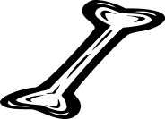
C3 – BONES
WHAT ARE THE FUNCTIONS OF THE SKELETON?

- Protection – Ribs protect heart and lungs, Cranium protects brain.
- Shape – gives framework - basketball player long, thin skeleton - jockeys small, thin skeleton
- Support – firm, rigid and keep us upright.
- Movement – Skeleton has ‘anchor points’ to which muscles attach and act as levers. Long bones help creates the leverage to apply the force.
- Blood Production – red and white blood cells are produced in the long bones.
HOW ARE BONES CLASSIFIED?
- Long bones – Humorous, Femur
- Short bones – Carpals and Tarsals.
- Flat bones – Cranium, Scapula and Sternum
- Irregular bones – Patella and Vertebrae. (odd shaped bones )

WHAT ARE THE 5 SECTIONS OF THE VERTEBRAE?

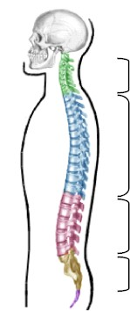
- Cervical – 7 vertebrae forms the neck and allows movement at top of the spine.
- Thoracic – 12 vertebrae. 10 are attached to ribs and help movement whilst breathing.
- Lumbar – 5 large and robust vertebrae. This area allows most movement.
- Sacrum – 5 vertebrae which become fused together in adulthood. They form part of the pelvic girdle.
- Coccyx – 4 vertebrae here, all fused together.
Come
To

Learn
Spinal

Column
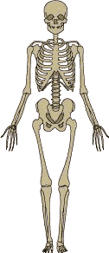
Cranium

Clavicle
Scapula

Sternum
Humerus

Ribs
Ulna

THE DEVELOPMENT OF BONES
Bones start off as cartilage and then become bone by the process of Ossification.
Bones have a tough outer layer called the Periosteum
As development continues there are 3 centres of ossification: in the diaphysis (middle) and epiphyses (end).

Ossification - The development of bone from cartilage. It occurs throughout childhood until adulthood.
Radius
Carpals

Ilium
Phalanges

Metacarpals
Femur

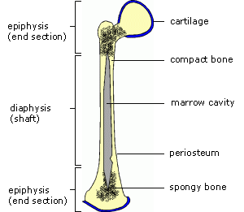
Patella
Metatarsals
Tarsals
Fibula
Tibia
Phalanges
(Growth plate)

WHAT TYPES OF JOINTS ARE THERE?

- Fixed (fibrous) joints - Skull
- Slightly moveable (cartilagineous) joints - Vertebrae
- Synovial joints or Freely Moveable – Knee/Elbow
IN WHAT WAYS DO JOINTS MOVE?

- Flexion: decreasing the angle at a joint.
- Extension: increasing the angle at a joint.
- Adduction: movement of a limb towards the body
- Abduction: movement of a limb away from the body.
- Rotation: movement of a limb in a circular or part circular direction.
C4 - JOINTS, TENDONS & LIGAMENTS

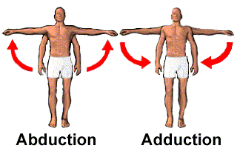
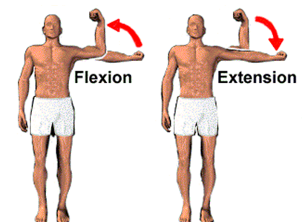

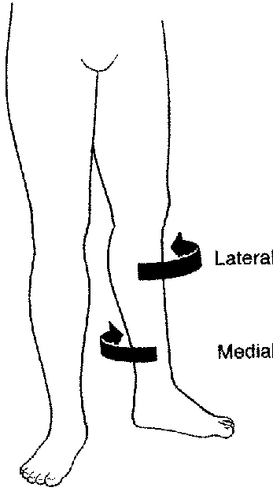

SYNOVIAL JOINT

Example – The Knee

Rotation

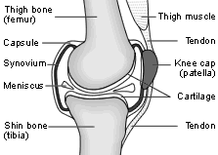

WHAT TYPES OF SYNOVIAL JOINTS ARE THERE?
- Ball and Socket – movement in all directions and rotation - Hip, Shoulder
- Hinge – movement Flexion and Extension - Knee or Elbow
- Pivot – only rotation at Atlas and Axis at top of the spine
- Gliding – Little bit of movement in all directions tarsals and carpals
- Condyloid – movement forwards and backwards, left to right - in the wrists

WHAT ARE TENDONS, LIGAMENTS & CARTILAGE?

TENDONS
- Attach muscle to bone
- Strong, non-elastic connective tissue
- Joint stability
LIGAMENTS
- Attach bone to bone
- Very strong elastic fibres
- Joint stability
CARTILAGE
- Covers joints to allow bones to rub smoothly
- Acts as shock absorber
- Produces synovial fluid

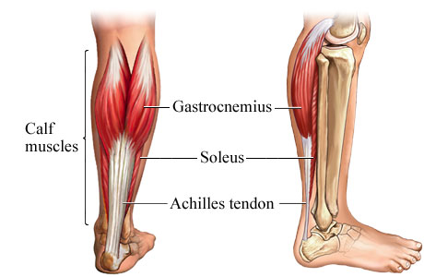
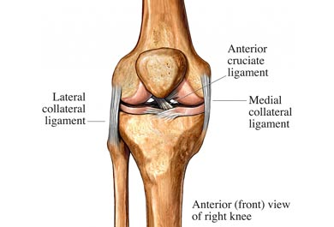
LIGAMENT

Bone

Cartilage

Bone
LIGAMENT
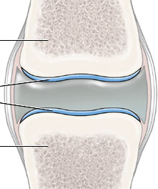

Gastrocnemius

TENDON (Achilles)

LIGAMENT
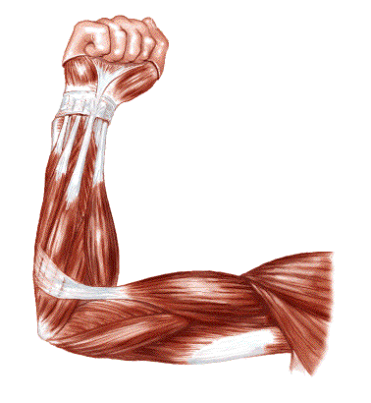
C5 – MUSCLES AND MUSCLE ACTION
HOW ARE MUSCLES CLASSIFIED?
- Skeletal (Voluntary) – most common. They attach to the skeleton, give a person’s shape – Biceps/Triceps
- Smooth (Involuntary) – work automatically and are not controlled - found in intestines, blood vessels and urinary organs.
- Cardiac (Involuntary) – involuntary and beats rythmatically – Heart Muscle

WHAT IS MUSCLE TONE?
Some muscle fibres contract whilst others relax. These contractions tighten the muscles but aren’t strong to cause movement. Different fibres contract at different times to prevent fatigue. This called Muscle tone and is very important for good posture.
MUSCLE TONE – Voluntary muscles in a state of very slight tension ready and waiting to be used

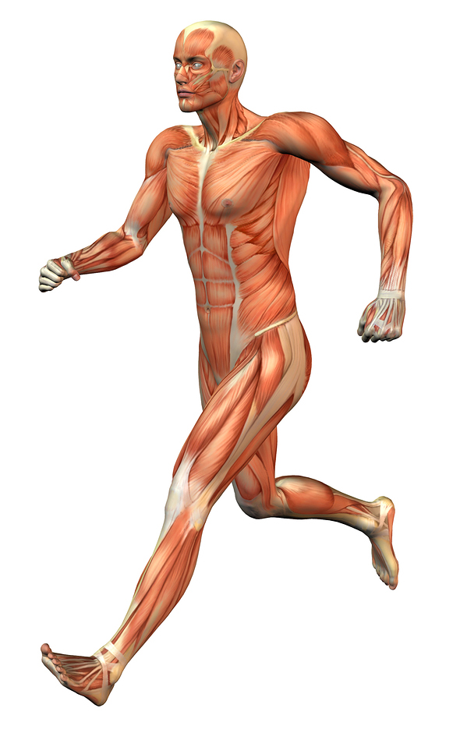

Deltoids
Trapezius

FAST TWITCH OR SLOW TWITCH?

FAST TWITCH
Used in explosive activities
Contract quickly
Produce powerful action
Limited Oxygen supply
White in colour
e.g. speed events, throwing & jumping

SLOW TWITCH
Used in endurance activities
Contract slowly
Long Lasting
Good oxygen supply
Red in colour
e.g. long distance running, cycling & swimming

Triceps
Pectorals

Biceps

Latissimus dorsi

Abdominals

Gluteals
Quadriceps

Hamstrings

Gastrocnemius

HOW DO MUSCLES WORK TOGETHER?
Antagonistic Pairs: Muscles working together to provide movement. E.g. Flexion of the arm, biceps contracts and triceps relax. To extend the arm, the triceps contract and the biceps relax.
- Agonist (Prime mover) – contracting muscle causing movement
- Antagonist – relaxing muscle that assists prime mover
- Origin – the end of muscle that is attached to a fixed bone
- Insertion – point where a tendon attaches muscle to bone where there is movement
- Flexibility – a joint’s ability to move through its full range
- bone where there is movement

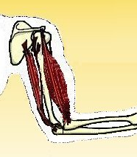
Origin

Agonist

Insertion

Antagonist

